# AUTOPILOT WiFi REMOTE

By

# Jack Edwards

This is a description of a remote control for operating the autopilot. The remote uses a nRF24L01+ wireless receiver/transmitter. A basic pair of these cost $6 USD. Though for this application I use the higher powered version for < $30.

Using this remote I am able to reliably receive data from the autopilot and send commands to the autopilot using the keypad. With the autopilot in my house, which is a thick walled adobe with a metal roof, I can operate the auto pilot from my shop in the next building 70 feet away. I have also tested this out of doors and can send and receive data 800 meters.

The need for a remote unit went all the way back to when I first started the Autopilot project. My first remote was a keypad in a small enclosure. It had a keypad to control the operating modes. It also had a knob for knob steering and a switch for run permissive. I wanted to add a display and looked at several options. To add an LCD was going to take two additional Ethernet cables which seemed cumbersome. I decided to build a remote using serial data transfer and use a 2.8 inch TFT screen from Adafruit. When I got it built it was not reliable and the Arduino Mega that it used would freeze up frequently.

Recently I came across the nRF24L01+ radio units. So I decided to try them. The project had a lot of new technical challenges but I now have several versions of the RF remote operating very well. Now that it is operating I realize that the problem with the previous serial remote was related to transmission of the serial data over a 25 foot cable. The problem could probably be solved using some sort of proper cable or data protocol.

PROJECT DESCRIPTION

I built two versions. One is battery operated and is wireless. It uses an LCD screen. The other is based on my old Serial remote and has cable for power, knob steering and switches. It uses the RF modules however to receive and transmit data back to the Autopilot.

The photo below shows the main autopilot and the two remotes.

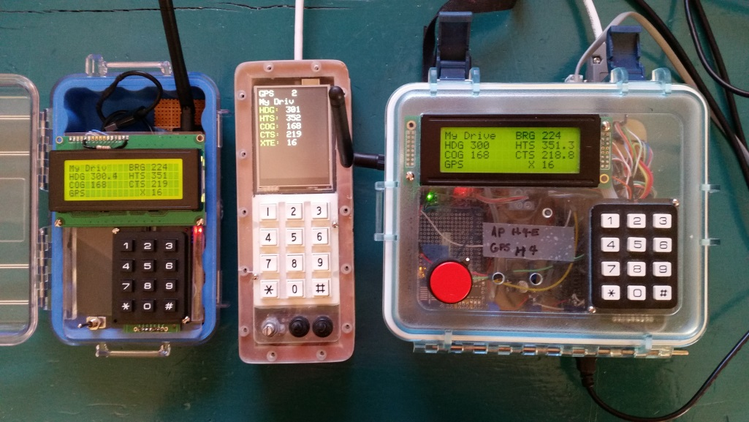

Figure 1 Autopilot main unit on the right, old Serial Remote converted to RF in the middle and the wireless RF remote on the left.

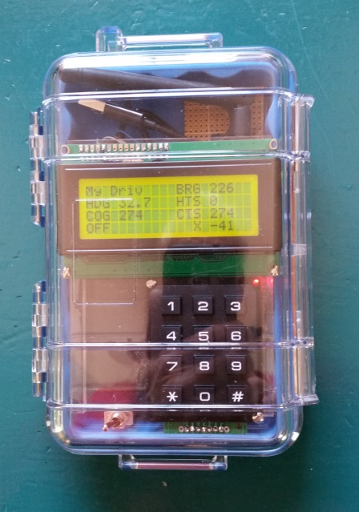 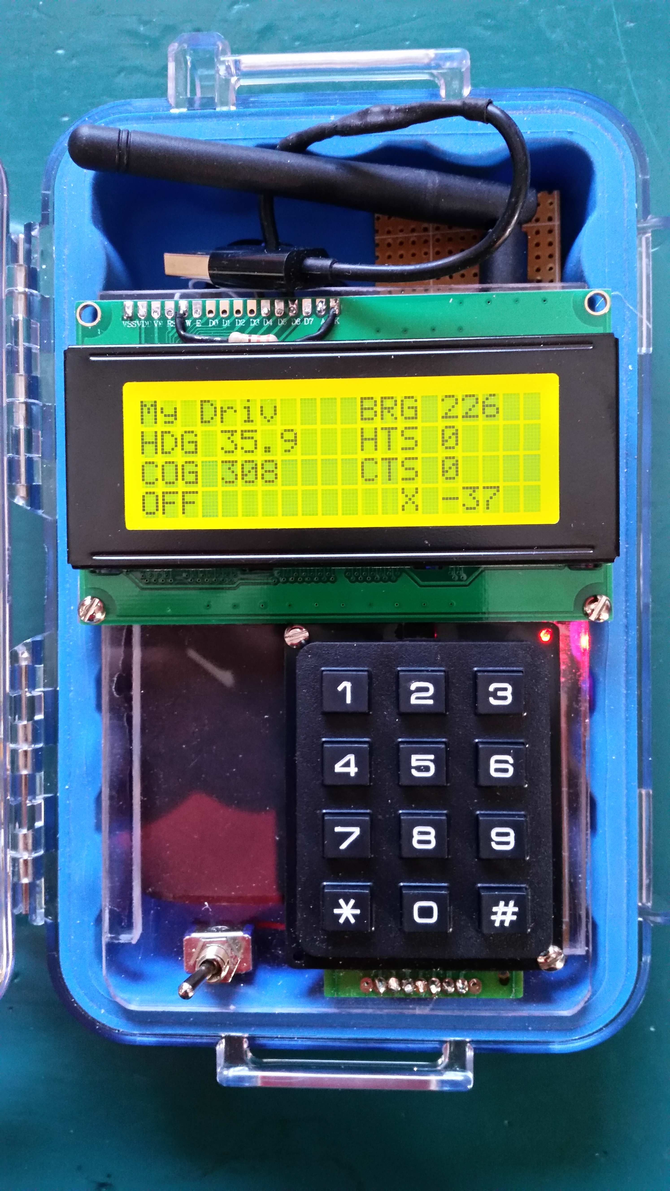

Figure 2 Autopilot Wireless RF Remote

Above are two photographs of the remote, one with the water tight box closed and one with it open. The box is a Pelican 1040 Micro case.

Below is a view with the components laid out. On the left is a small perf board with an Arduino Micro mounted and the RF board with a power supply board.

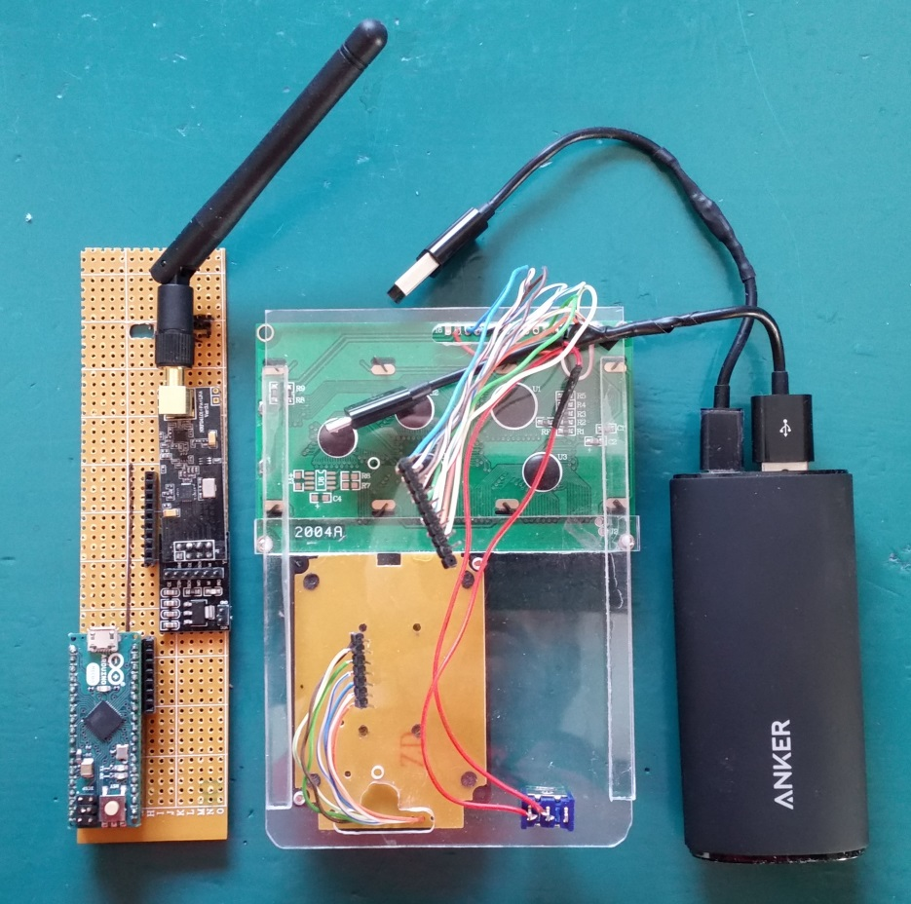

Figure 3. Component layout.

In the middle is Plexiglas mounting board. The LCD and keypad are mounted on the top of the Plexiglas. To the right is an ANKER cell phone external battery. This one has a capacity of 6000 mAhr. I did a 36 hour test and used 75% of the battery capacity.

Below is a close up of the perf board. Upper left is the Arduino Micro <https://www.arduino.cc/en/Main/ArduinoBoardMicro>

Just below the Arduino is a 7 pin female header socket where the keypad plugs in.

Same line to the right is 9 pin female header socket to plug in the LCD.

Below that is the high power RF module, a 3.3 V power supply and an antenna.

The radio is here for $13.50. <http://yourduino.com/sunshop2/index.php?l=product_detail&p=190>

Power supply board, $1.25. <http://yourduino.com/sunshop2/index.php?l=product_detail&p=467>

Antenna, $1.50. <http://yourduino.com/sunshop2/index.php?l=product_detail&p=191>

Best general guidance for using the radios is here: <https://arduino-info.wikispaces.com/Nrf24L01-2.4GHz-HowTo>

One of the things I learned in developing this remote is that the radios require 3.3 V and the Arduino Mega can only output a small current on the 3.3 V pin. Using the power supply board uses a 5V in and it can come from the USB supply. BE SURE YOU ONLY POWER THE RADIOS WITH 3.3 V.

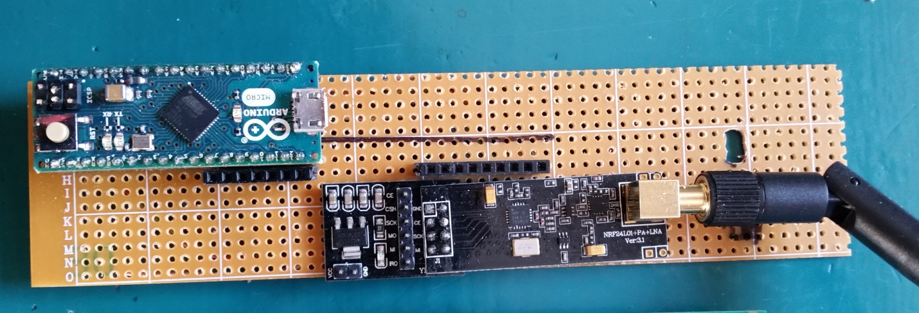

Figure 4. Perforated prototype board showing Arduino Micro and the RF24L01+ radio module with power supply board.

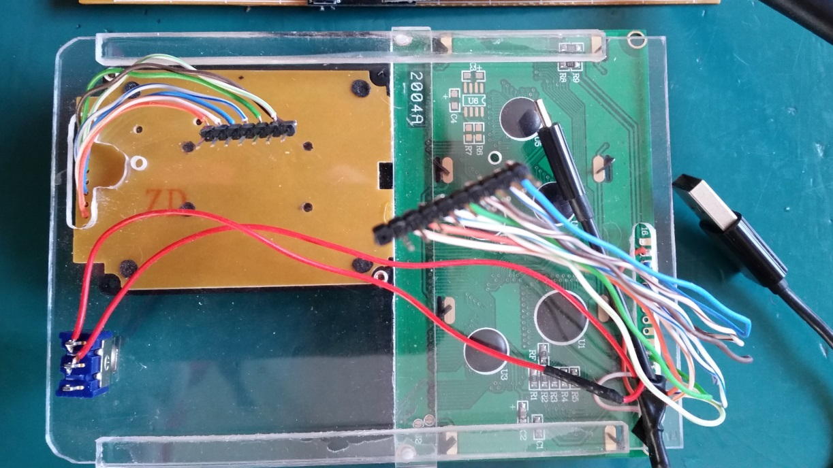

Figure 5. Plexiglas board with keypad and LCD viewed from the bottom. There are two ¼ x ¼ rails glued to the sides of the Plexiglas that fit down into the Pelican micro case that hold the board. Also there is a piece of Plexiglas glued across the board (vertical in this view) that the LCD is bolted to. The holes in the LCD are just a little wider than the Plexiglas plate.

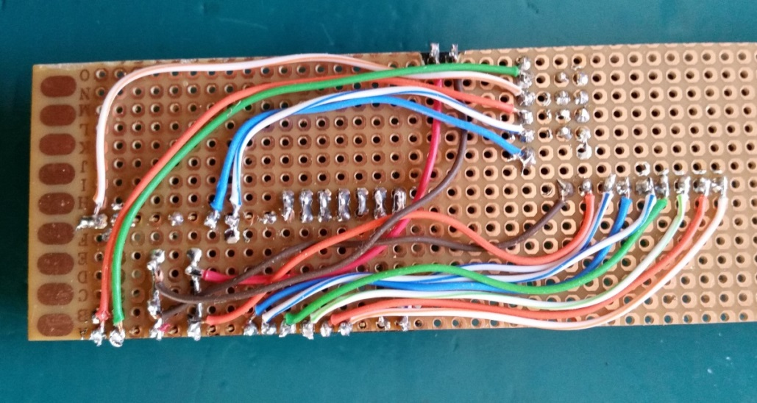

Figure 6. Back side of the Perf board showing the wiring layout.

ANKER BATTERY The battery uses a USB micro cable to supply power to the Arduino and the RF power supply. The cord has been cut and an ON – OFF switch wired in. Only the red and black power wires have been reconnected. A second USB micro cable has been shortened and connected to the ANKER charging port so the ANKER battery can be recharged without having to remove it from the remote.

<http://www.ianker.com/product/79AN7902-W2A>

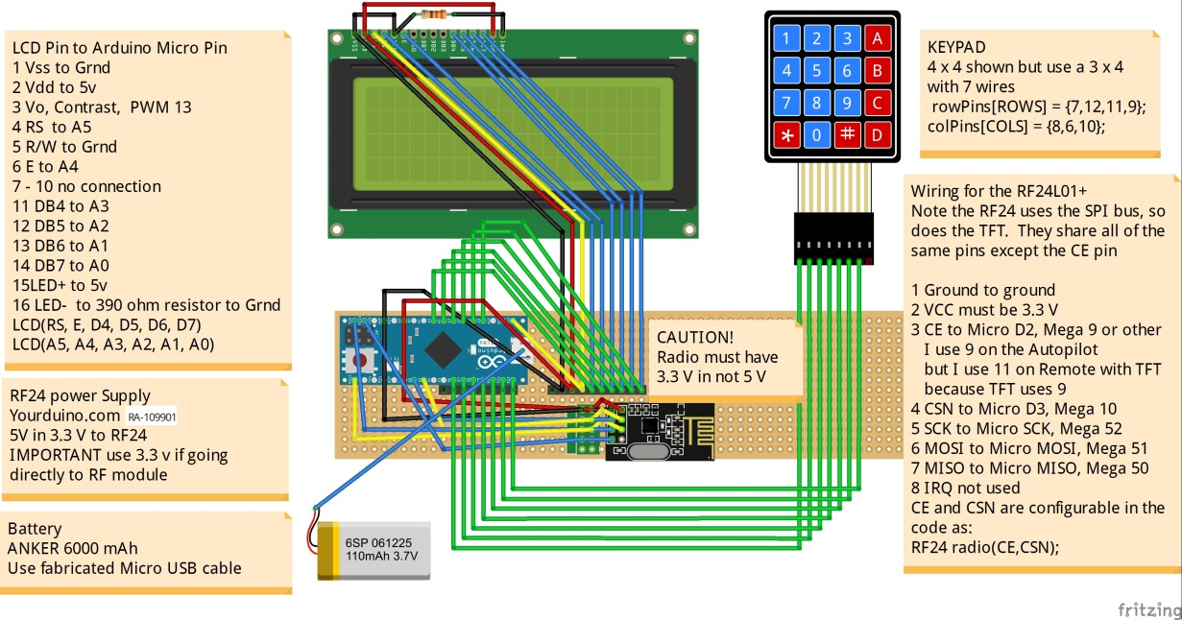

Figure 7. This is a wiring schematic using the free Fritz software. This is the Fritz file JNE RF Remote.fzz.

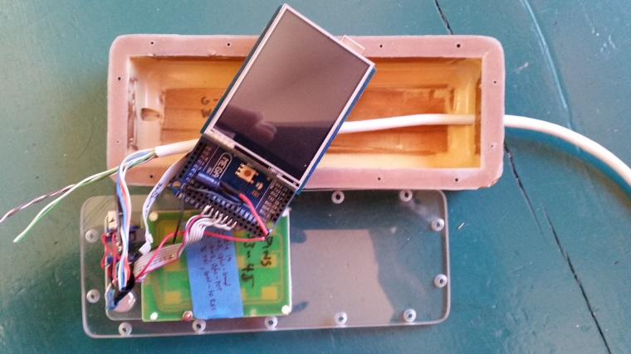 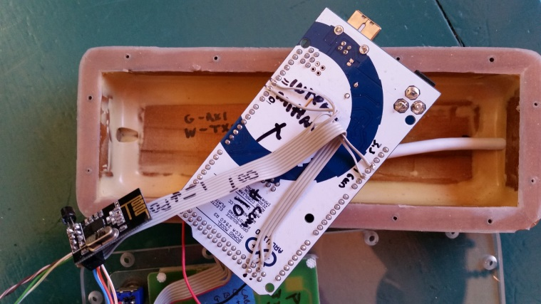

Figure 8. Component views of the RF remote based on the old Serial remote.

These two photos show the the old Serial remote converted to RF. In the photo on the left you can see the Arduino Mega with the TFT screen plugged in, wires going to the switches and potentiometer for knob steering, and a ribbon cable connecting the keypad to the Arduino. In the photo on the right the Arduino is turned over and you can see the nRF24L01+ and the ribbon cable wiring to the back of the Arduino for the RF24. This is the standard RF24 not the high powered version. It seems to be adequate between the cockpit and the navigation table where the Autopilot is. The Autopilot has a high powered module and is the one that is sending all of the data to the remote. The remote only has to send keypad signals to the Autopilot. If I were doing this from scratch I would use a high powered module but there is not enough room in this enclosure.

In the development of the RF remote I started with a a model that had both an LCD and TFT. One of the issues with the TFT is that is quite slow in refreshing the screen. My concern was that when you push a button you want to see a response and I found the LCD much quicker and that is why I developed both. After everything was working I revised the program so it only prints values on the TFT when they have changed a half of a degree. This eliminated the time consumming full screen refresh each cycle. As a result the TFT response is as good as the LCD.

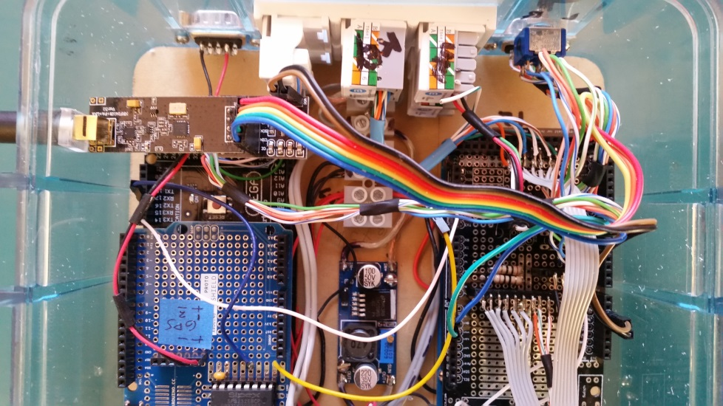

Figure 9. A view of the Main Autopilot showing installation of the RF24 high powered radio and power supply board. The radio is in the upper left in the photo. It uses the rainbow ribbon wire and is plugged into the header sockets of the Autopilot wiring shield. See the Fritz diagram for the pin assignments.

In conclusion I would say there are a number of ways one can build a remote to suit their own preferences. The software has user input to to select which screen is used and which pin assigments are used for the various componets.